Exp 4

Step 1: shut down the ubuntu server

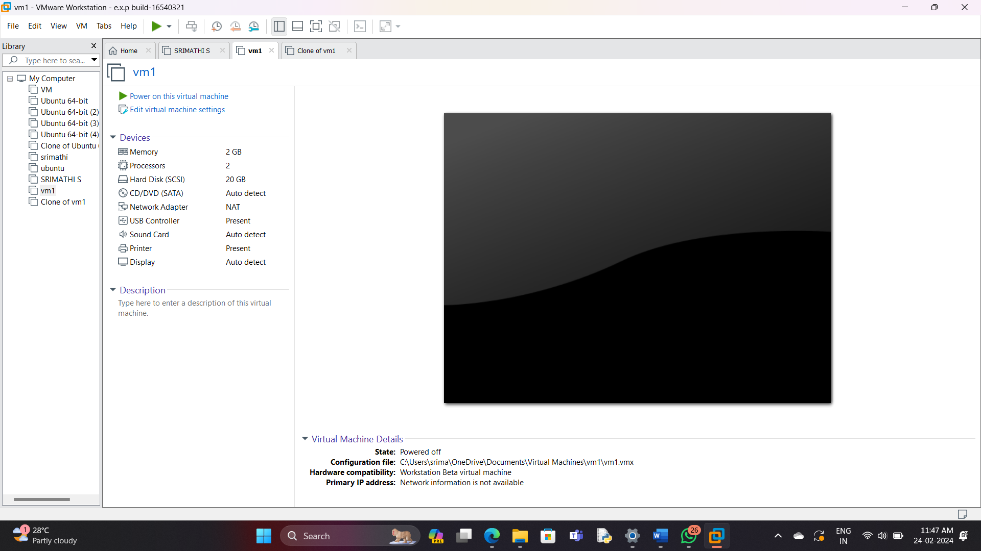

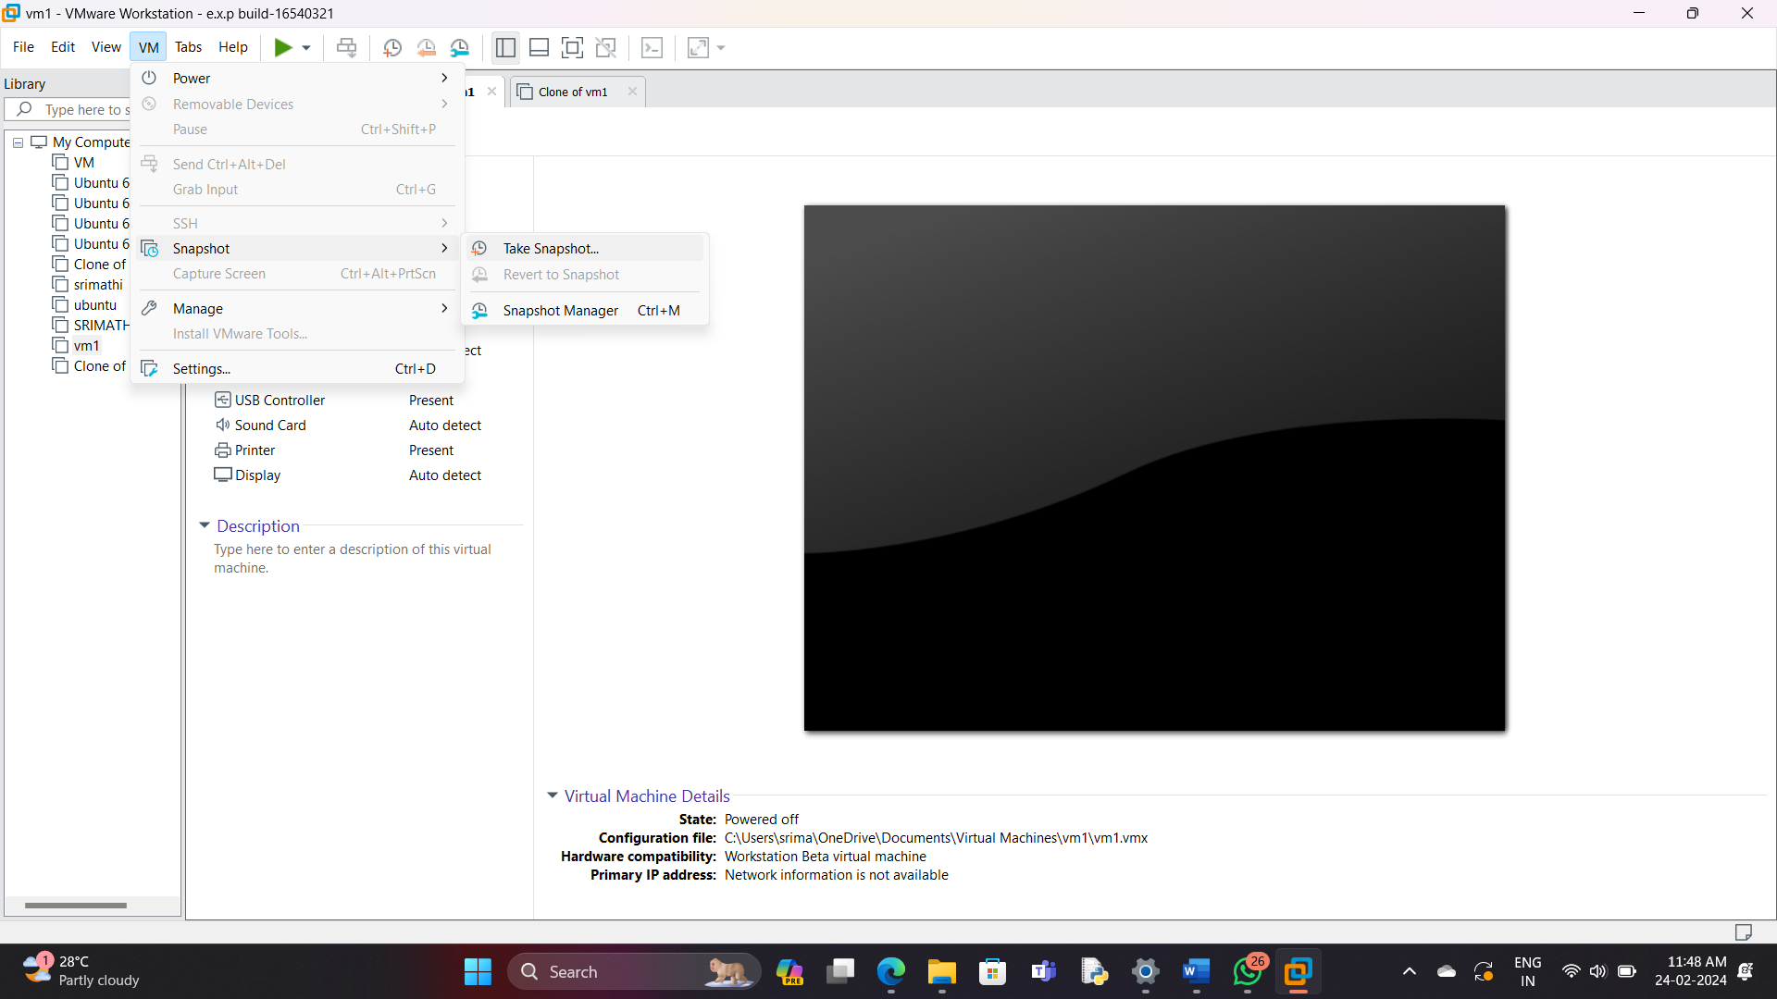

Step 2: Take a snapshot and save it as snapshot 1.

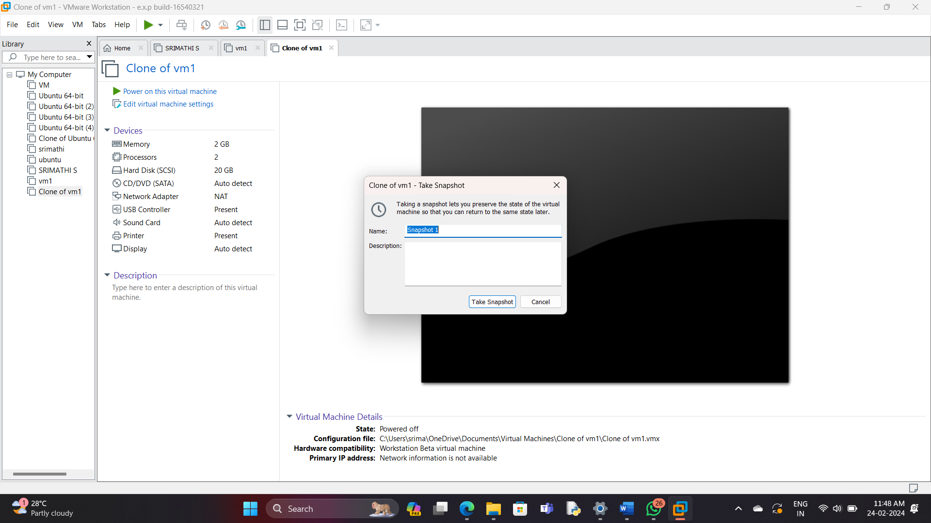

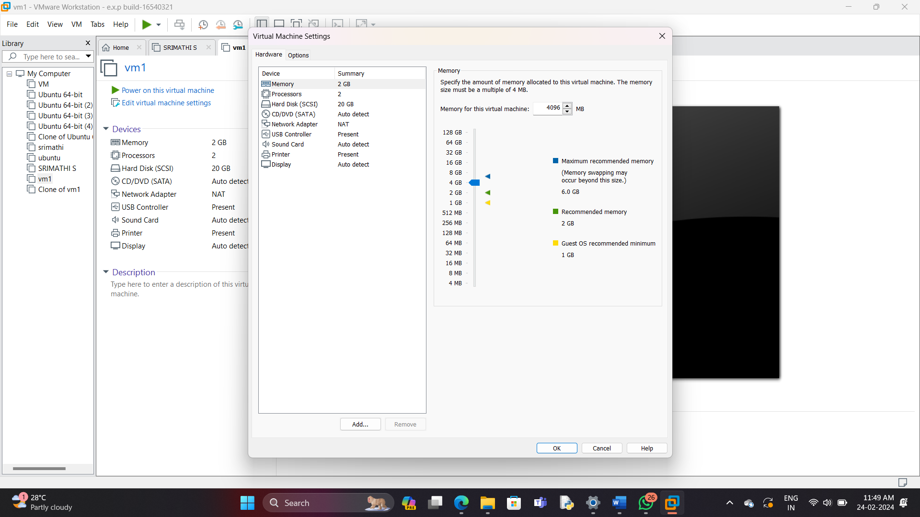

Step 3: change the RAM memory to 1 GB

Step 4: change the processor core to core 1

Step 5: Take a snapshot ans save it as snapshot 2

Step 6: Add the hard disk 15GB .

Step 7: take a snapshot and save it as snapshot 3.

Step 8: open snapshot manager

Step 9: choose snapshot 1 ,and switch to snapshot 1

Step 10: switch to snapshot 1 by clicking “go to”.

Step 11: click on “yes”

Step 12: the snapshot 1 has been retrieved .But the other snaps has been deleted .